MKT-101 (DMAN)

**Class 01:- Lecture 00**

Introduction

------------------------------------------------------------------------

**Class 02:- Lecture 01:- Fundamentals of Marketing**

Introduction

**What is marketing?** (Marketing is a process)

Marketing is not about selling.

Marketing is very similar to gardening. When we are nursing a garden we giving them (tree) different treatment depending on their nature also same in marketing. In marketing we need to target a group and read their demand after collecting the data marketer lunching the products.

**03 work for Marketer.**

1. Identify the right group of customers or consumer.
2. Develop an appropriate products/ offers/services for them.
3. Managing profitable customer’s relationship.

**What is not marketing?**

* Selling and advertising
* Telling and selling
* Fishing
* Hunting

**What is marketing? (Likes a gardening process)**

* Sensing and Responding
* Gardening
* Meeting need profitably

**A product for everyone a product for no one.**

------------------------------------------------------------------------

**Class 03:- Lecture 02:- Fundamentals of Marketing**

Philip Kotler is an American marketing author

**According to the Philip Kotler marketing is a social and managerial process whereby individuals and groups obtain what they need and want through creating and exchanging value to each other.**

**Key Words-**

* Social process
* Managerial process
* Value

Some Core Marketing Concepts

**1. Markets**

* Customers

Market is a set of actual and potential buyers.

(Customers expansion or buyers’ expansion)

**A product for everyone a product for no one.**

**2. Needs, Wants and Demands.**

**Needs: -** Needs means feeling deprivation or feeling empty. (Feeling hungriness, feeling need a vacation or travelling less etc.)

**Wants: -** It’s a form of needs shaped by culture and personality. (I want a hamburger, Bangladeshi people eat rice etc.)

**Demands: -** It’s a form of wants backed by the purchasing power. (I have money to buy hamburger or for Maldives vacation etc.)

------------------------------------------------------------------------

**Class 04:- Lecture 03:- Fundamentals of Marketing**

**3. Value and Satisfaction**

(Equation of Value)

**Value= Total Benefits – Total Costs** (Time costs, opportunity costs, searching costs.)

**So, value means the difference of total benefits and total costs**

When the total benefits is less than the total cost is known as a Negative Value.

**Satisfaction= Value – Expectations or Expectations- Value**

* Value > Expectation = Delighted.
* Value < Expectation = Dissatisfied.
* Value = Expectation = Satisfied.

**Now Marketers say “Never promise over”**

* **What can be marketed?**

Marketers are engaged in marketing 10 or more than 10 types of entities:

* **Goods:-** Physical goods ( anything touchable likes laptop, mobile phones, camera)
* **Services:-** Work of airlines, hotels, car rental firms (likes school, pathao, uber)
* **Events:-** Promoting trade shows, artistic performances (likes wedding event, music festival)
* **Persons:-** Celebrity marketing, film star has an agent, a manager ( likes Shakib-Al-Hasan, M.S.Dhoni, Messi, V. Kholi)
* **Places:-** Cities, regions compete to attract tourists, headquarters (likes Goa, Indonesia, Singapore, Las-Vegas )
* **Properties:-** Intangible right of ownership of property/ assets (likes Mona Lisa’s picture, Taj-Mahal)
* **Organizations:-** Work to build a strong, favorable, and unique images in the minds of target publics (likes non profitable organization, university, UNICEF)
* **Information: -** Can be produced and marketed as product.
* **Ideas: -** Every market offering includes a basic idea.

------------------------------------------------------------------------

**Class 05:- Lecture 04:- Fundamentals of Marketing**

* Some information about USA and China economy.
* The difference between USA and China economies are.

China have production based economy or China have more physical goods than USA on the other hand USA have less factory but they have world class brands or USA have more services based product than China.

USA have more pattern based business and USA is a passive income model.

In market we find

2 types of Buyers

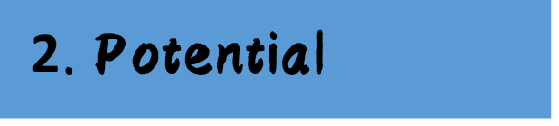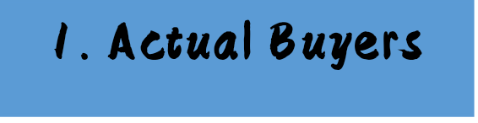

**1. Actual Buyers:** The people who punches the goods immediately or use the products immediately.

**2. Potential Buyers**: The people who punches the goods in future or future customers.

* **3 characteristics of a Potential Buyers.**

**1. People who exhibit needs.**

(People who need the products or goods or who interested)

**2. Resources to exchange.**

(People who have enough money for exchanges)

**3. Willingness to exchange.**

(People who have desire to purchase)

**Market:** Buyers who share a particular need or want that can be satisfied through exchange or relationships…

Modern Marketing System

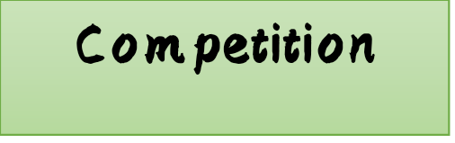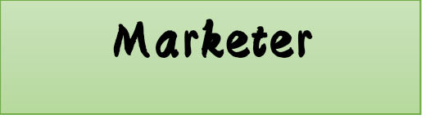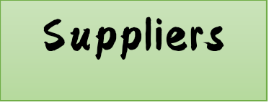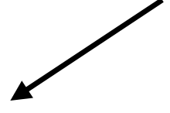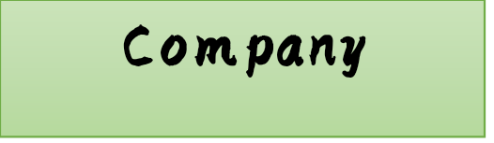

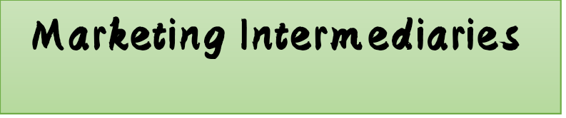

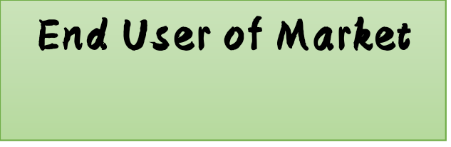

Both company and competition need good relationship with suppliers.

A company should have a good relationship with competition. **(HEALTHY COMPETITION)**

------------------------------------------------------------------------

**Class 06:- Lecture 05:- Fundamentals of Marketing**

* Company orientation/ Marketing Philosophies/ Company Concepts

**(Different company use this concept in different way)**

* **Production Concept**

In Production Concept the company believed that if the price of a product is cheap and if the product is available in everywhere then they sell their best.

Challenge: Company loss people trust because people believed cheap product never go long.

* **Product Concept**

In Product Concept the company believed that if the product have high quality and if the product is good with other feature then the company sell their best no matter what is the price.

Challenge: Company loss a specific group of customers. (Like Company loss meddle class or lower class customers.)

* **Selling Concept**

In selling Concept the company believed that the more you promotion the more you sells. In this concept company give more and more advertisement or promotion.

Challenge: Always promotion is never attract people for buy the products and production cost will be increase also product price will be high.

* **Marketing Concept**

In marketing concept the marketer identify the right group of customers or consumer, develop an appropriate products/ offers/services for customers and managing profitable customer’s relationship. After that a company produce their products.

Like I-Phone Company use marketing and product concept.

* **Societal Marketing Concept**

In societal marketing concept a company should be run their business profitably but they should give some of their profit to our society. So as a result a company never get all the profit they need to invest their profit for develop the society.

Challenge: Sometime some of company try to cheat with society.

------------------------------------------------------------------------

**Class 07:- Lecture 06:- Fundamentals of Marketing**

* **Social Marketing Concept**

In social marketing concept the product will solve a big or burning problems. I will business with that product and other side my products can also solve a big problem of society. Social marketing concept will deal with social crisis. It will profitable also. In this concept products should be a problem solving products.

* **Social Business Concept**

In social business concept this concept is very similar to social marketing concept but the difference is that a company can’t profit with this concept. Company have to reinvest the profit amount for the wellbeing our society.

Challenge: Some of company never follow ethics of this concepts they profit for their own.

* **Customer Concept**

In customer concept it is a one to one marketing concept or it’s known as one to one product (like customized products, tailoring, customized design)

Challenge: this concept not for regular or cheaper goods.

**Talk about the assessment 1 (until the marketing mix slide)**

-----------------------------------------------------------------------

**Class 08:- Lecture 00**

**QUIZ - 01**

**ASSESSMENT - 01**

------------------------------------------------------------------------

**Class 09:- Lecture 07:- Fundamentals of Marketing**

**Marketing Mix-**

**Marketing mix is a set of some controllable tools through what marketer can influence their customers.**

Marketing mix elements are those which a marketer can use to satisfy a customer’s needs successfully as a marketer. A marketer can use those elements to make products more attractive. Those elements are under control of a marketer**.** Marketing mix is a combination of 4Ps which are (Product, Price, Place and Promotion) it is also known as 4Cs which are (customer’s solution, customer’s cost, customer’s convenience, customer’s communication) product is a controllable goods

**Product oriented business have 4 controllable tools**

1. Product
2. Price
3. Place
4. Promotion

**Services oriented business have 7 controllable tools**

1. Product
2. Price
3. Place
4. Promotion
5. People
6. Process
7. Physical evidences

On the other hand, if marketing mix for services related business so here in not 4ps here are 7ps which are (Price, Product, Place, Promotion, People, Process and Physical evidences).

All business are have 2 categories.

1. **Product:** Product means which we can touch or tangible goods
2. **Services:** Services means which we cannot touch or intangible goods.

Product is a thing of customer’s solution. Fast Moving Consumer Good (FMCG). Unilever is one of the famous FMCG in Bangladesh

------------------------------------------------------------------------

**Class 10:- Lecture 08:- Fundamentals of Marketing**

**Product: -** Product means customers solution.

* **Product variety:** Product variety means a company need some variety on their product because variety product attracted customers. (Like Unilever have soap variety Lux, Lifebuoy, Dove etc.)
* **Quality:** A marketer need to create quality products that buyers want. Like I-Phone.
* **Design:** A product needs to have many different designs then the customers will be easily attracted towards the products. (Like Unilever have soap variety Lux, Lifebuoy, Dove etc.)
* **Features:** A product need to have all the features that a customer want.
* **Brand name:** A business or product must be need a brand name otherwise customer never finding your product. Brand name attracted customers because brand name different your product from other products.
* **Packaging:** Packaging is the main thing that attracted a customer to the products it is very important for profit in business.
* **Sizes:** Which sizes customer want or need a marketer must to know because a customer need 50g but your product will be 100g. So, we can say sizes is an important thing.
* **Services:** A product must have a services policy like guarantee or fittings services free which are attracted customer.
* **Warranties:** Warranties means after buying the product customer have some special facilities. Which known as warranties.
* **Returns:** Returns policy is not available in Bangladesh.

------------------------------------------------------------------------

**Class 11:- Lecture 09:- Fundamentals of Marketing**

**Price: -** Product means customers cost.

* **List price:** List price means different product and different price for different customers like Unilever produce Lifebuoy which price is low on the other side Lux which is little bit higher from lifebuoy and Dove which is little bit higher from Lux.
* **Discounts:** Basically discount is a sales promotion. By discount people attracted to the .product. Like Bata give 20% discount on purchasing up to 5000 taka.
* **Allowances:** Allowances means gift to the customers or reward.
* **Payment period:** Payment period means a company need to all type of system of payment. Like 6 months or 12 months installments.
* **Credit terms:** Credit terms means pay through credit card or visa card. If the system of payment is easy so the customer love to buy.

------------------------------------------------------------------------

**Class 12:- Lecture 10:- Fundamentals of Marketing**

**Promotion: -** By promotion people know about the information about product or variation of product 3 characteristics of promotion which are non-personal communication, paid form of communication and there should be an identifiable sponsor.

* **Sales Promotion:** Sales promotion means boosting sales through giving discount.
* **Advertising :** Advertising is known as television commercial (TVC)

3 characteristics of Advertising

1. Non-personal communication

2. Paid form of communication

3. There should be an identifiable sponsor

* **Sales Force:** Sales force means one to one or face to face promotion or personal selling. Sales force only for luxury goods or costly goods. It is not for all types of goods.
* **Public Relations:** Public relation means relation with some public who are directly or indirectly involve with the company. A company need 360 degree relation (likegood relation with stock or stack holder, media public, general public or local public and law and enforcements etc.)
* **Direct Marketing:** Direct marketing is not a face to face promotion. In direct marketing there are no physical meeting. Here company communicate with their customers through e-mail, massage etc**.** Direct marketing is known as permission marketing.

------------------------------------------------------------------------

**Class 13:- Lecture 11:- Fundamentals of Marketing**

**Place: -** Place is an impotent things for a company where the company’s office build or where the industry will build.

* **Channels:** What to send and how to send the product to the customers. Through/ types/ strategy is known as channels.
* **Coverage:** Coverage means covering areas, district or division through established brand shop. Like RFL shop in Khilgoan, Buddha Mandir etc.
* **Assortments:** Knowing which product will be presented to customers at what time is known as assortments.
* **Locations:** Where the shop will be open deciding the perfect location is very important for a company or business. Like library shop in front of school.
* **Inventory:** Stored products are presented to the customers as per their needs or requirement is known as inventory. Which known as a supplies change management.
* **Transport:** Transport means the transportation system of a company.

4cs

* Customers Cost.
* Customers Solution.
* Customers Convenience.
* Customers Communication.

**Holistic Marketing Concept:** In holistic marketing concepts the marketer thing about the 360 degree about the consumers also they thinks about the worker, supplier, dealer, competitors etc.

**The New Marketing Realities**

* **Network information technology** (now everything turn into network information technology)
* **Globalization**
* **Deregulation** (deregulation means government policy and law etc.)
* **Privatization** (nowadays every company is changing in privatize which known as privatization)
* **Heightened competition** (nowadays the competitions is so high)
* **Industry convergence** (now everything turn into industry sector)
* **Consumer resistance** (now consumer trust is a big problem)
* **Retail transformation** (nowadays the retail are big like Agora, Meena Bazar etc.)
* **Disintermediation** (it’s means cutting down the middle man)

**New Consumer Capabilities**

* **A substantial increase in buying power.** (now public have a big or own purchasing power)
* **A great variety of available goods and services.** (many substitutes are available in market now)
* **A great amount of information about practically anything.**
* **Greater ease in interacting and placing and receiving orders.** (easily product receive or order)
* **An ability to compare notes on products and services.**
* **An amplified voice to influence public group.** (every people have their own opinion which influence public group)

------------------------------------------------------------------------

**Class 14:- Lecture 12:- Consumer Markets and Consumer Buying Behavior**

**Consumer:** Consumer means the person who use the products.

**Customer:** Customer means the person who buy the products but never use.

Consumers are the person who finally use the product like father buy a chocolate for his son here father is a customer and son is a consumer.

A person or a company who purchases the product for re-selling is known as business markets. People purchasing product for 2 reason-

* Consumer market**/ for use.**
* Business market**/ for re-selling.**

Fast Moving Consumer Goods [FMCG]

Model of buyer Behavior---

Behind the every buying there are 2 stimuli

| Buyer Characteristics and Buyer decision process |
| --- |

1. Marketing Stimuli

* Product, Price, Place and Promotion

2. Other Stimuli

* Economic, Technological, Political and Cultural

**Factors influencing consumer behavior**

| **Cultural** | **Social** | **Personal** | **Psychological** |  |
| --- | --- | --- | --- | --- |
| Culture | References Group | Age and life-cycle | Motivation |  |
| Sub-culture | Family | Occupation | Perception | **Buyer** |
| Economic Situation | learning |
| Social Class | Roles and Status | Lifestyle | Beliefs and attitude |  |
| Personality and self-concept |

**Culture: -** Culture is a set of values, norms and attitude. It different in every country. Every country or every human group have their own culture. **[Sociologist say culture is a melting pot]**

**Sub-culture:-** Sub-culture is a part of culture. Like Bangladeshi people like to eat rice and fish. **[Sociologist say sub-culture is a salad box]**

**Social class: -** Social class means classify the people in a society or classify a people to another people measured by- middle class, lower class, educated, uneducated and occupation etc.

If a marketer thing about all of this then produce their product then they will be make more profit.

------------------------------------------------------------------------

**Class 15:- Lecture 13:- Consumer Markets and Consumer Buying Behavior**

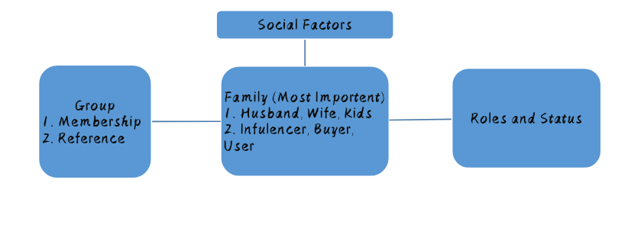

**Reference Group (2 part)**

**1. Direct** {Those people who influence our life directly or those people we following. Like our Idle.}

* **Primary** {Small, informal group like friends, relatives.}
* **Secondary** {Large, formal group like neighbor.}

**2. Indirect**

* **Aspirational** [Motivational, desired to be a member like LM10’s follower hate CR7 here LM10 is aspirational.]
* **Non- aspirational** [Non-motivational like CR7 follower hate LM10’s here LM10 is non-aspirational.]

**Consumer Decision Making: Family Buying Roles—**

* **Initiator:** At first the person who rise their hand about buying products like housekeeper known as initiator.
* **Influencer:** The person known as influencer is the most influencing person for which product will be buy which brand will be it.
* **Decider:** Most of the time the person who sponsor money for buying product is known as decider or normally the decider will be head of the family.
* **Buyer:** Normally the person who buy the product from the market is known as buyer.
* **User:** User means the person who finally use the products.

1 person will be play all of this roleor play one or more role

Family Life-cycle

* A series of stages.

**Talk about the assessment 2 (Factors Affecting Consumer Behavior: Personal slide)**

------------------------------------------------------------------------

**Class 16:- Lecture 00:-**

**ASSESSMENT – 02**

------------------------------------------------------------------------

**Class 17:- Lecture 14:- Consumer Markets and Consumer Buying Behavior**

In this modern time marketer say that “a child is a consumer before they birth”

**Factors Affecting Consumer Behavior: Personal.**

* **Lifestyle Identification**
* **Activities:** Doing anything. Like listing music or reading.
* **Interest:** What I love to do. Like which music I love to listen hip hop or classic.
* **Opinion:** Opinion means someone personal opinion, like I am a supporter of Bangladesh cricket team.
* **Personal Influence**
* **Age and life cycle stage:** In this stage we need products on depends on our age. Every people have different age and different need. Like when a child birth they need some products on the other hand when the child growing they need some different product. In every different age child need different products which we call as age and life cycle stage.
* **Occupation:** Occupation means after passing university people do job. The planning where, how, when they expenses their salary is occupation. Like travel in Bali, Purchasing gift for family members. For change in occupation people needs different different products. Like the person who work in a corporate office he/she needs formal dress formal shirt or the person run their own business they don’t need formal dress.
* **Economic situation**: Economic situation means financial condition.
* **Personality and self-concept:** Extrovert and introvert.

**Maslow’s Hierarchy of Needs**

* **Physiological needs:** Human’s fundamental or basic needs. Example: food, cloth, education, treatment and house etc.
* **Safety needs:** We know people love to live with full safety which are safety needs like life jacket, insurance company, (Volvo the world safest car).
* **Social needs:** Every people wants some recognition from their society want some love from their family members which we call social needs like an Apartment Company.
* **Esteem needs: (Self-esteem)** Humans are want more recognition from their society or more love from their family which known as esteem needs or self-esteem like Mercedes Benz corporate cars.
* **Self-actualization:** Self-actualization means satisfaction like travelling company, Be what you can be (American Navy).

------------------------------------------------------------------------

**Class 18:- Lecture 15:- Consumer Markets and Consumer Buying Behavior**

**Type of Buyer Decision** **Behavior**

In our society there are 4 types of Customer

1. **Habitual Buying Behavior:** Low involvement product here buyer never think about the brand, buyer buy the product without plan [like vegetables].
2. **Complex Buying Behavior:** High involvement product here the customer think about the brand. Customer compare each and every brand after that they buy their products [like cosmetic].
3. **Varity Seeking Behavior:** Low involvement product here the customer never think about the product before purchasing, although here brand matters but the never compare with other brand. Here consumer buy the product what they decided before [like soft drink].
4. **Dissonance:** High involvement product here customer never know about the brand but they compare the product with other products [like carpet].

**Buyer Decision Process**

Before purchasing the product customer follow some steps

1. **Needs Recognition:** Before purchasing product customer take some decision which is call recognition. Some customer buy some product without any query but some of customer buy a product thinks a lot.
2. **Information Search:** Information search means when customer search the information that where they find the best products where the find best price or discount.

* Personal sources {family, friends, relatives}
* Commercial sources {Advertisement, sales people}
* Public sources {Mass media or mass communication}
* Experiential sources {User of the products, handling the products}

1. **Evaluation of Alternative:** We know most of the product have some alternative when a customer evaluate the alternative with other is known as evaluation of alternative.
2. **Purchase Decision:** Taking decision about the purchasing.
3. **Post Purchase Behavior:** After purchasing the products the consumers satisfaction or dissatisfaction or consumer opinion [like this food is good or bad]

------------------------------------------------------------------------

**Class 19:- Lecture 16:- Consumer Markets and Consumer Buying Behavior**

**Stages in the Adaption Process**

* **Awareness:** In this stage consumers are aware about the products but here consumers never find the enough information about the products. This is the stage where the consumer first listen about the products.
* **Interest:** In this stage consumers collect more information about the new products.
* **Evaluation:** Here consumers compare the products and evaluate the products also in this stage consumers considers trying the new products.
* **Trial:** In this trial stage consumers try the products for the first time.
* **Adaption:** After trial if the products satisfy the consumer then the consumer decided to make regular use of this products here the consumer adapted the product for regular use.

Adapter Categories

* Innovator 2.5% [They purchase before the product launching]
* Early Adapter 13.5% [After launching they buy immediately]
* Majority Adaptor 34% [After some days of early adaptor the majority buy the product]
* Late Adaptor 34% [They buy at the before end time of the product]
* Laggards 16% [They buy at the end time of the product]

Influence of Product Characteristics on Role of Adoption

* **Communicability:** In this role a company must give enough information about their product of a consumer [like Bangladesh Biman].
* **Relative Advantage:** Compare with other brand. A product must need to have some unique thing.
* **Compatibility:** Find that is the combination match with the target grope of customer.
* **Complexity:** Everything will be simple because consumer love to purchase with simple thing.
* **Divisibility:** Giving the trial policy.

**Class 19:- Lecture 16:- Demand Management**

**Demand: An economic principle that describes a customer’s desire and willingness to pay a price for a specific good or service.**

**Types of Demand**

There are 08 types of demand---

1. **Negative Demand:** Here consumer need this services but they have a negative mind about the services. Some time they never accepts this product [like dental care or air travel].
2. **No Demand:** On this consumer have no interest about the product and the consumer never know about the product [like new farming system].
3. **Latent Demand:** Desire or demand than consumer unable to satisfy like after having this product a consumer never satisfied [harmful cigarette]. When people smocking them never find any utility but people always search the best brand for cigarette.

------------------------------------------------------------------------

**Class 20:- Lecture 17:- Demand Management**

1. **Declining Demand:** When the demand of a product will fall down is known as declining demand [like National University].
2. **Irregular Demand:** Sometime the demand is rise or sometime the demand is fall [like seasonal food business, office hour rickshaw rent]
3. **Full Demand:** When a company equal to its demand it is known as full demand. This type product have always demand which we call demandable goods.
4. **Overfull Demand:** In the overfull demand the demand of products in higher [like the theme park is terribly overcrowded].
5. **Unwholesome Demand:** It is an illegal act [like hard drinks, alcohol] people wants to control it, strict law should be follow, young stars need council etc.

**Class 20:- Lecture 17:- Market Segmentation, Targeting and Positioning for Competitive Advantage**

**Market Segment: -** A group of customer which needs and wants are same

**Market Segmentation: -** Segmenting the targeted group by their profession [like if I produce pen then where I sales those pen].

------------------------------------------------------------------------

**Class 21:- Lecture 18:- Market Segmentation, Targeting and Positioning for Competitive Advantage**

If a company produce their goods for everyone then its call no market segmentation.

For every product it is not possible for fully segmented.

If the segmentation is gender wise it is different for men/male and different for women/female.

Segmentation will be age wise this segmentation depends on age.

**Why should we go for segmentation?**

* By segmentation a company grouping their customers.

**Effective Segmentation Criteria**

* **If a company launching a shampoo in market of Dhaka, Bandar, Chittagong. So if the company collects information about the user then they can segmented.**
* **Substantial:** Segment must be large enough. If the people of Chittagong use the shampoo one time in a year so it is not profitable for the shampoo company.
* **Differential:** Here all the segment are different like if a company launching a pen here they never differentiate boys and girl if it will be a dress company then it is must that the company differentiate boys and girls.

**We can segment the market through 4 types**

1. **Geographic:** Segments depends on location and environment. Dhaka, Chittagong, Weather. Different products are sold in different areas.
2. **Demographic:** Segments depends on age, gender, family, life cycle. Like in a small family they need small furniture but big family need more furniture than small family.
3. **Psychographic: This segments depends**

* **Personality-** Extrovert or introvert.
* **Motives-** Means motivated ness.
* **Lifestyle-** Sports oriented, cultural oriented.

1. **Behavioral:** It depends on action. Occasion, benefits, user status etc. like if a person came a restaurant every day for a cup of coffee then he is a loyal customer.

**Target**

**Undifferentiated Targeting Strategy:** When a company produce a product without targeting a group its means it is an Undifferentiated Targeting Strategy.[Like when a Chanachur company produce chanachur they never thing about class. They produce chanachur for everyone].

**Multi Segment Targeting Strategy:** When a company targeting group by class, occupation etc. like Unilever produce soap depends on working class. Lifebuoy for a sports person and lux for female.

**Concentrated Targeting Strategy:** In this strategy a company concentrated that which product produce for who here the group of customers are decided before the product produce.

**Positioning**

High Quality



A

G E D

C B

Low Price High Price

F

Low Quality

------------------------------------------------------------------------

**Class 22:- Lecture 00:-**

**Presentation**